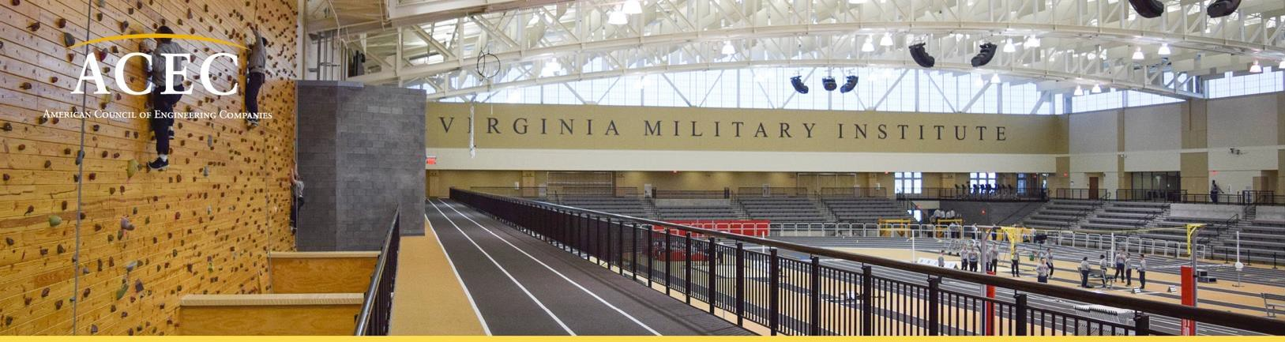

ACEC Young Professional of the Year Award
Guidelines

This award is intended to recognize the accomplishments of our young professionals who have contributed to the engineering profession and impacted society.

1. Name of Award: ACEC Young Professional of the Year

2. Nominations: Nominations for this award shall only be made through Member Organizations (MO).
A nominee shall be employed at a member firm of their respective MO. No more than two (2) nominations shall be submitted per MO.

- Nominations are due to the applicable MO prior to the ACEC deadline. Check with your MO for their submission date.

b. Nominations from the M.Os are due to ACEC by C.O.B Friday, May 5, 2023 and submitted electronically to Heather Talbert, htalbert@acec.org.

c. All nominations must be complete and submitted electronically on the nomination form provided. d. Incomplete nomination forms may delay processing and not meet the deadline.
3. Evaluation and Selection of Nominees: The evaluation of the nominees for the award will be made by the Young Professional Awards Subcommittee of the Fellows Committee. The Sub-committee will recommend the top 5 nominees to the Fellows Committee. Five (5) awards will be given each year.

4. Criteria for Award:
a. The nominees shall be employees of ACEC member firms.

b. The nominees shall be engineers 35 years of age or younger as of December 31, 2023, to apply for the following year program.

c. The nominees shall be a registered Professional Engineer.

5. Recognition:
a. All winners will be recognized in person at ACEC’s Fall Conference.

b. The top Young Professional Award Winner will receive complimentary registration from the College of Fellows to attend the 2024 ACEC Business of Design Consulting education program.

