ACEC Young Professional of the Year
Nomination Form (must be completed for each nominee)
Nominations for this Award shall only be made through Member Organizations

Completed nomination form shall be submitted to the Member Organization and address indicated below:
Name of Member Organization Address City, State & Zip Code

Telephone

Email

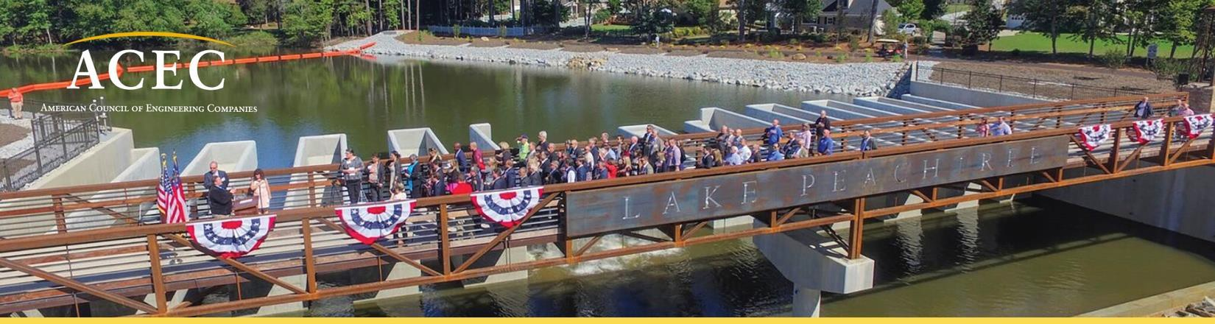

A. Nominee’s Information

Name:

Position or Job Title:

Employer:

Work Address:

Work Phone:

Email:

Age as of December 31, 2023:

Education

School(s) and Location:

Degrees and Majors:

Professional Registration

State(s):

P.E. Registration Number (s) (PE and/or other professional registrations):

Discipline(s):

B. Nomination Statements

Provide two statements of 250 words or less each supporting the nomination on a separate sheet of paper. Facts presented should include engineering achievements in design, research, development, and/or management during the last two to five years, and their importance. Provide two supporting statements:

1. One from the nominee (250 words)

2. Second from the nominee’s employer/firm (250 words)

C. Volunteer Activities: Provide your responses on a separate sheet of paper to the following:

1. List your professional organizations and your role in each.

2. List your recent community volunteer activities and your role in each activity.

3. Write 250 words or less essay on your most recent significant achievement for your professional or community volunteer activities.

D. Technical and Leadership Questions: Please attach responses on a separate sheet of paper to the following two questions.

1. Describe to date, your most technically challenging project and how you resolved the issue. (200 Words Only)

2. How would you describe your leadership style and how you would motivate the team? Provide example.
(200 Words Only)

E. For publicity purposes, share your employer’s Public Relations contact and the names and addresses of two publications in the nominee’s hometown.

1. Public Relations Contact:

Telephone and Email:

2. Publication Name:

Address:

3. Publication Name:

Address:

F. How did you find out about this award?

□ From my employer
□ From State MO
□ Facebook
□ Twitter
□ Other (please specify)

G. Photos

Headshot: Candidates must provide an electronic color headshot of high-quality resolution suitable for publication at least 1MB (jpg, tif, or eps). Business attire is recommended.

H. Photograph Consent and Release

Note: a scanned signature is acceptable.

I, the undersigned, grant my consent and permission to publish my photograph and use my name solely for purposes of advertising, publicizing, and promoting the ACEC Young Professional of the Year program.

I hereby release and agree to hold harmless ACEC from any liability, and invasion of any right of privacy or publicity, arising out of the use of my name and photograph.

I acknowledge that I have read and understand this Consent and Release prior to signing it. I certify and warrant that I am of legal age and have the full power, right, and authority to enter into this consent and release.

Signature of Young Professional

Print Name:

Date:

Sponsoring Information

ACEC National Staff Contact: Heather Talbert

Phone: 202-682-4377

Email: htalbert@acec.org

ACEC State Member Organization:

Name:

Phone:

Email:

Firm Staff Contact:

Firm Name:

Contact Name:

Phone:

Email:

