Builders Risk Insurance Coverage for Utility Projects
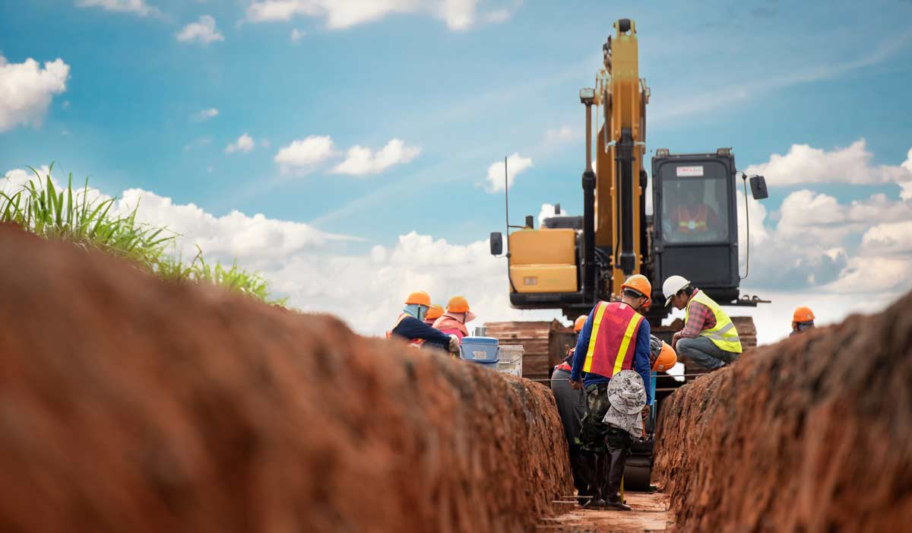

A Joint Recommendation of the Carolinas AGC/NC/SC ACEC Committee: April 2022

What is Builder’s Risk Coverage and how is it used on Utility Projects?

Builders Risk Insurance is designed to cover damage caused by a peril to property under construction or damage to materials that are to become a part of a building, structure, or project. Coverage includes materials that are in transit as well as materials temporarily stored on or away from the project location. Pipeline or portions of projects related to pipeline are typically limited to specific perils covered under Builders Risk therefore need additional consideration when developing coverage for these services. Alternative coverage solutions for utility installation may include but are not limited to installation floater, higher deductible options or self- insuring materials.
Builder’s risk is distinguishable from project liability insurance (contractor’s commercial general liability insurance) or an architect’s professional liability policy, which provides third party coverage. These policies cover liability suffered by third parties and do not cover or reimburse costs of the insured party. Builders Risk is a temporary form of first party property insurance that ends once construction is completed or as defined by policy terms.
Coverage should be bound effective the earliest of the following dates: 1. Date required by owner or lender. 2. Prior to any vertical construction beginning. 3. Prior to transportation of materials. 4. Prior to materials being stored onsite or at an off-premises location.
Builder’s risk can be obtained on a project specific basis or a master Builder’s Risk program to cover a contractor’s or owner’s portfolio of projects. These policies are intended to cover the interests of owners, contractors and subcontractors as single point coverage solution in the event of a covered loss.
The Prime Contract should define if Builders’ Risk coverage is required, which party is responsible to purchase the Builder’s Risk (owner or general contractor,) and outline acceptable deductibles and sub-limits. Builder’s Risk policies may differ, so it is important that the owner/contractor read and understand the coverage language included in the Builder’s Risk policy and relay set forth such information in the Prime Contract.
Typical Damage from Covered Perils

To be covered under a Builder’s Risk policy, damage must be caused by a Covered Peril:

- Fire.
- Lightning.
- Theft.
- Vandalism.
- Malicious Mischief.
- Collapse.
- Debris Removal.
- Demolition required by law.
- Flood.
- Named Windstorm.
- Testing.
- Earthquake.
- Mudslide.
- Riggers Liability; and
- Soft Cost.

Note that policies differ, and some may sublimit the amount of coverage available to losses caused by some of these perils and therefore should be reviewed for adequacy.

Notable Builder’s Risk Exclusions
The following are normal exclusions from Builder’s Risk Coverage:
  - Wear and Tear.
  - Corrosion, Decay, Defects.
  - Leaks in Plumbing.
  - Contractor’s Equipment.
  - Dishonest acts by the insured.
  - Unexplained Inventory Shortages.
  - Lifting loads exceeding manufacturers’ recommendations.
  - Errors or Omissions in the Design or Specifications; and
  - Motorized Vehicles.
Optional Coverages Added by Endorsement
There are optional coverages that can be added to policies by Endorsement to cover aspects of projects that may be different project to project. These optional coverages include:
- Delay in completion, including gross profits, rental income and soft cost;
- Contract Penalties.
- Crane re-erection expense.
- Off-premises service interruption.
- Reward Payments.
- Spare Construction Material.
- Emergency Property Protection Expense.
- Design Professional Fees.
- Coverage for aspects of green building construction.
- Permission to occupy; and
- LEG (London Engineering Group) 3: enhanced protection for faulty design/workmanship.
Installation Floater

An Installation Floater provides coverage for damage to property that will become part of a finished product during installation and while in fabrication, transit or temporarily stored at an offsite location.
Installation floaters:
- Potential product savings of up to 20% to 30% vs standard builders’ risk policy;
- Are often included in a builder’s risk policy but can be purchased separately.
- May be a good option to cover materials on a pipeline project.
- Provide coverage until the work is accepted by the project owner.
- Can be project specific or for the portfolio of projects.
- Are typically purchased by the contractor.
- Coverage is isolated to the contractor that purchases the policy; and
- Examples of potentially covered items:
  - Materials intended for installation being stored on project site.
  - Materials intended for installation in transit or being stored offsite.
  - Piping, electrical wiring, conduit, pre-cast structures; and
  - Does not include coverage for contractor equipment being used for installation.

When do you need Builders Risk vs Installation Coverage?

BUILDERS RISK | INSTALLATION
- Need to cover all project contractors, trades & owner | - Only need to cover an individual contractor
- Need to insure larger/complex project scopes: (structures, pump stations, fixed building) | - Only need to cover a single trades work, (utility installation, water/sewer pipe)
- Need to cover hard costs, soft costs, delay, etc. | - Only need to cover exposed material being installed

Summary
- Installation rates are typically 20%-30% less than builders’ risk rates;
- Be sure to read and understand the insurance specifications in your contract.
- If Builder’s Risk is required, but not purchased, you could be “out of pocket”.
- If you purchase a policy, understand the fine print (deductibles, sub-limits, exclusions and claim reporting requirements);
- Whether the owner or GC is providing the Builders Risk, make sure you understand the coverage and any deductible requirements, including which party is financially responsible for the deductible payments and that this is clearly reflected in the construction agreements.
- When Builder’s Risk coverage is provided by another party, make sure you have waiver of subrogation language in your contract that’s in your favor; and
- When requesting quotes from your broker/insurer, make sure they have a clear understanding of your project and ample time based on project location (month in advance for high catastrophic areas).

